Test: Programming-3

AksheshKumar Chaudhari(301087120)

Output:

1.

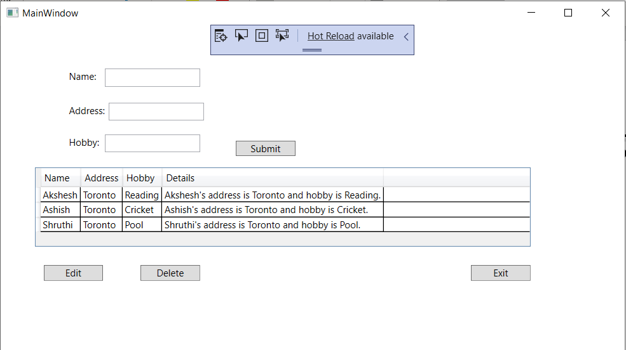

2.

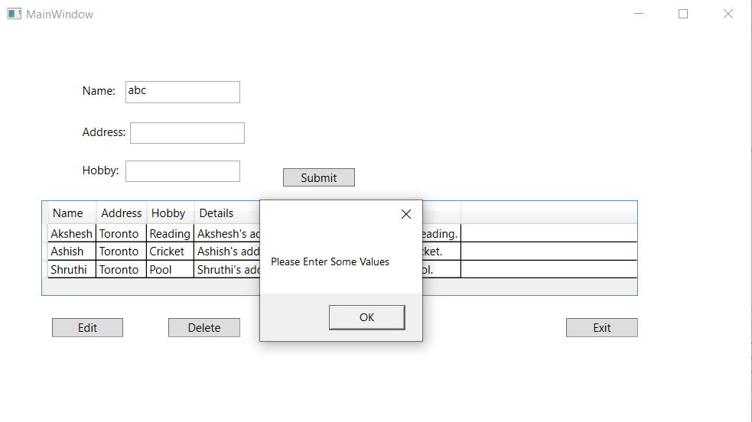

3.

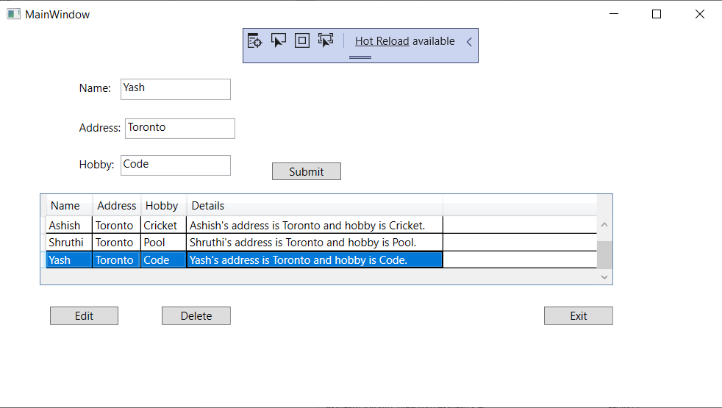

4. validation on Edit and delete button

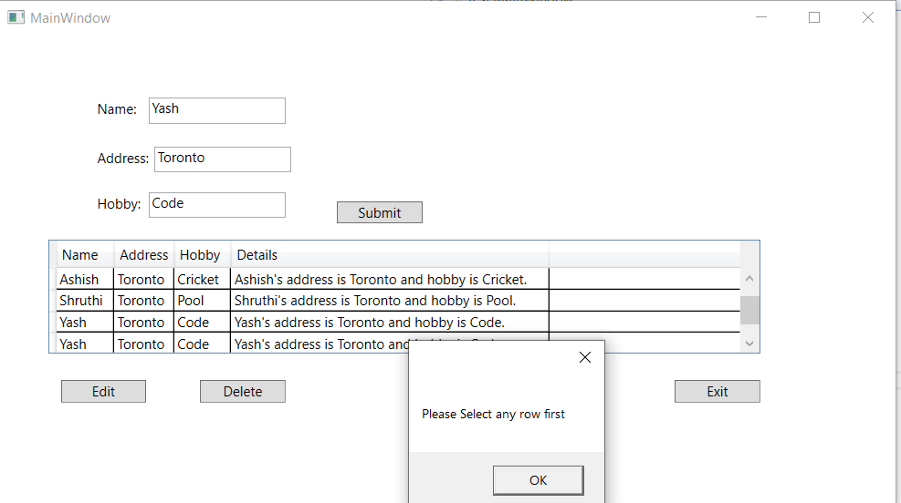

5. Yash’s detail is deleted

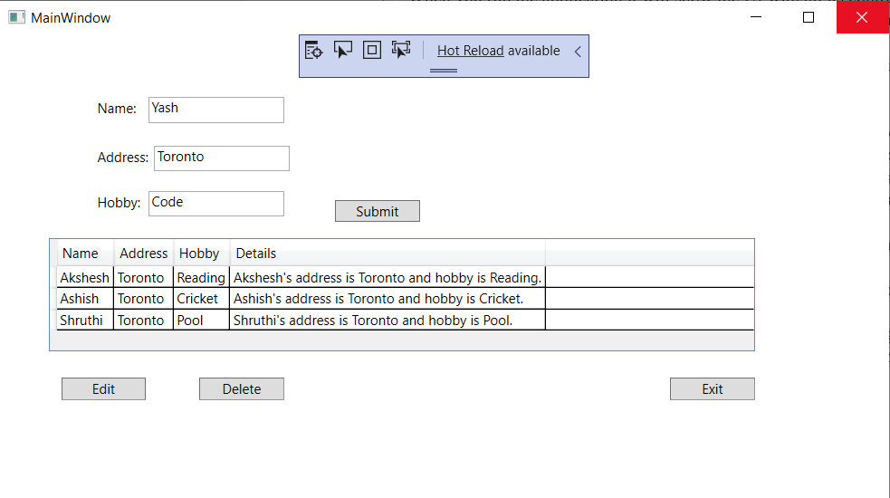

6.Shruthi’s hobby has been changed from pool to Basketball

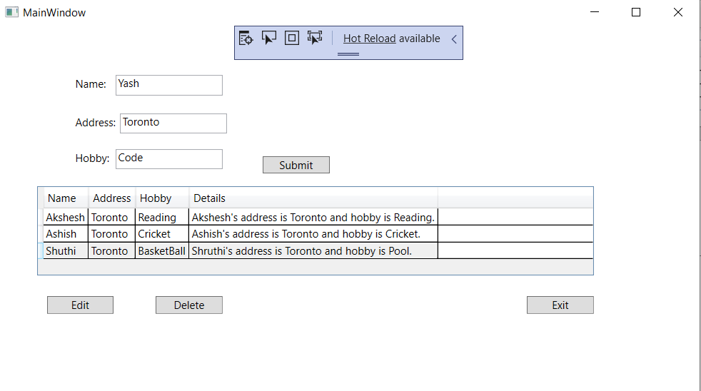

7. Exiting the app

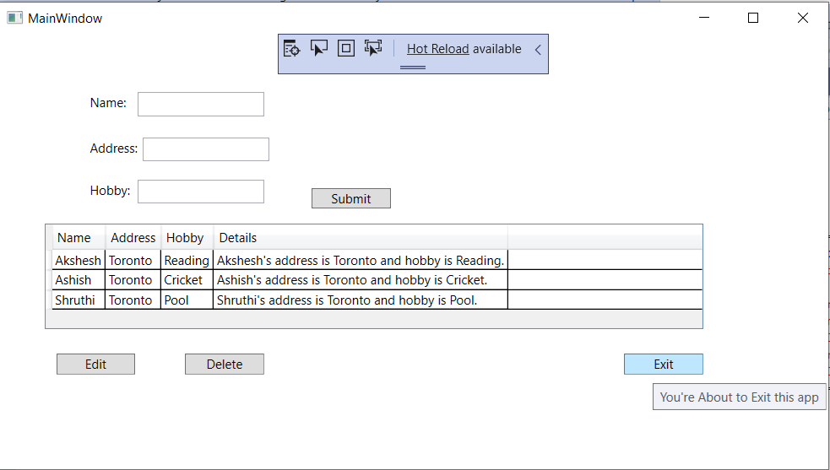

Code:

MainWindow.cs

using System;

using System.Collections.Generic;

using System.Linq;

using System.Text;

using System.Threading.Tasks;

using System.Windows;

using System.Windows.Controls;

using System.Windows.Data;

using System.Windows.Documents;

using System.Windows.Input;

using System.Windows.Media;

using System.Windows.Media.Imaging;

using System.Windows.Navigation;

using System.Windows.Shapes;

namespace Test

{

/// <summary>

/// Interaction logic for MainWindow.xaml

/// </summary>

public partial class MainWindow : Window

{

List<Info> infos = new List<Info> { };

public MainWindow()

{

InitializeComponent();

infos.Add(new Info("Akshesh", "Toronto", "Reading"));

infos.Add(new Info("Ashish", "Toronto", "Cricket"));

infos.Add(new Info("Shruthi", "Toronto", "Pool"));

dg1.ItemsSource = infos;

}

private void Submit_Click(object sender, RoutedEventArgs e)

{

if (tbName.Text.Length >= 1 && tbAddress.Text.Length >= 1 && tbHobby.Text.Length >= 1)

{

dg1.ItemsSource = null;

infos.Add(new Info(tbName.Text, tbAddress.Text, tbHobby.Text));

dg1.ItemsSource = infos;

}

else

{

MessageBox.Show("Please Enter Some Values");

}

}

private void Exit_Click(object sender, RoutedEventArgs e)

{

Close();

}

private void Delete_Click(object sender, RoutedEventArgs e)

{

if (dg1.SelectedIndex == -1)

{

MessageBox.Show("Please Select any row first");

}

else

{

infos.RemoveAt(dg1.SelectedIndex);

dg1.ItemsSource = null;

dg1.ItemsSource = infos;

}

}

private void Edit_Click(object sender, RoutedEventArgs e)

{

if (dg1.SelectedIndex == -1)

{

MessageBox.Show("Please Select any row first");

}

else

{

infos.ElementAt(dg1.SelectedIndex).Name = tbName.Text;

infos.ElementAt(dg1.SelectedIndex).Address = tbAddress.Text;

infos.ElementAt(dg1.SelectedIndex).Hobby = tbHobby.Text;

// infos.Add(new Info(infos.ElementAt(dg1.SelectedIndex).Name, infos.ElementAt(dg1.SelectedIndex).Address, infos.ElementAt(dg1.SelectedIndex).Hobby));

infos.RemoveAt(dg1.SelectedIndex);

infos.Add(new Info(tbName.Text, tbAddress.Text, tbHobby.Text));

}

}

}

}

Class File(info.cs) code:

using System;

using System.Collections.Generic;

using System.Linq;

using System.Text;

using System.Threading.Tasks;

namespace Test

{

class Info

{

public string Name { get; set; }

public string Address { get; set; }

public string Hobby { get; set; }

public Info(string name, string address, string hobby)

{

Name = name;

Address = address;

Hobby = hobby;

}

public string Details

{

get

{

return

String.Format("{0}'s address is {1} and hobby is {2}.", this.Name, this.Address,this.Hobby);

}

}

}

}

XAML File Code:

<Window x:Class="Test.MainWindow"

xmlns="http://schemas.microsoft.com/winfx/2006/xaml/presentation"

xmlns:x="http://schemas.microsoft.com/winfx/2006/xaml"

xmlns:d="http://schemas.microsoft.com/expression/blend/2008"

xmlns:mc="http://schemas.openxmlformats.org/markup-compatibility/2006"

xmlns:local="clr-namespace:Test"

mc:Ignorable="d"

Title="MainWindow" Height="450" Width="800">

<Grid>

<Label Content="Name:" HorizontalAlignment="Left" Margin="81,52,0,0" VerticalAlignment="Top"/>

<TextBox x:Name="tbName" HorizontalAlignment="Left" Height="23" Margin="131,55,0,0" TextWrapping="Wrap" VerticalAlignment="Top" Width="120"/>

<Label Content="Address:" HorizontalAlignment="Left" Margin="81,95,0,0" VerticalAlignment="Top"/>

<TextBox x:Name="tbAddress" HorizontalAlignment="Left" Height="23" Margin="136,98,0,0" TextWrapping="Wrap" VerticalAlignment="Top" Width="120"/>

<Label Content="Hobby:" HorizontalAlignment="Left" Margin="81,135,0,0" VerticalAlignment="Top"/>

<TextBox x:Name="tbHobby" HorizontalAlignment="Left" Height="23" Margin="131,138,0,0" TextWrapping="Wrap" VerticalAlignment="Top" Width="120"/>

<DataGrid x:Name="dg1" HorizontalAlignment="Left" Height="132" Margin="43,166,0,0" VerticalAlignment="Top" Width="624" />

<Button x:Name="Submit" Content="Submit" HorizontalAlignment="Left" Margin="286,141,0,0" VerticalAlignment="Top" Width="75" Click="Submit_Click" RenderTransformOrigin="-0.027,-0.937"/>

<Button x:Name="Edit" Content="Edit" HorizontalAlignment="Left" Margin="54,303,0,0" VerticalAlignment="Top" Width="75" Click="Edit_Click"/>

<Button x:Name="Delete" Content="Delete" HorizontalAlignment="Left" Margin="176,303,0,0" VerticalAlignment="Top" Width="75" Click="Delete_Click"/>

<Button x:Name="Exit" ToolTip="You're About to Exit this app" Content="Exit" HorizontalAlignment="Left" Margin="592,303,0,0" VerticalAlignment="Top" Width="75" Click="Exit_Click"/>

</Grid>

</Window>